United for Health Care


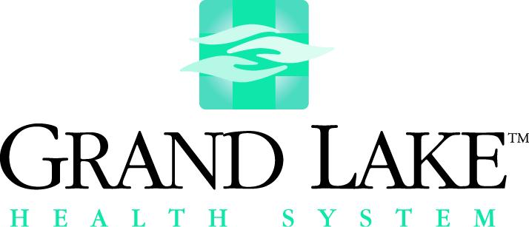

January 24, 20007 Contact: Marty Dodrill
419-394-3387, ext. 3567
Ken Obringer
419-678-5613
FOR IMMEDIATE RELEASE
Area Health Systems Combine Efforts For Community Health

Mercer Health and Grand Lake Health System jointly announced today that they are combining their efforts to bring several community health programs to area residents. This joint effort is an extension of cooperative efforts that have been done in the past.
This new community service program is called “United For Health Care”. The two health systems will be working together to improve the health of residents in the area.
“We are pleased to work with Mercer Health improving the health status of our communities,” said Kevin Harlan, President and CEO of Grand Lake Health System and Joint Township District Memorial Hospital. “Health promotion is important to the mission of both Grand Lake Health System and Mercer Health. We look forward to working together on health education programs and health fairs of all types.”
Interim Chief Executive Officer at Mercer Health Jim Wermert said, “The first combined program is the annual Spring Health Fair. This is an excellent opportunity for us to work with Grand Lake Health System to educate the community about steps they can take to improve their health.”
The first community program in which the two health systems will combine efforts will be a Spring Health Fair at the Auglaize-Mercer Family Y on State Route 703 on Saturday, March 24, from 7:30 to 11:00 a.m. The joint statement stated, “This was a natural project for us to combine efforts since it was something we have both done at this time of the year in the past. We will be offering the same screenings as in the past, but hopefully in a more efficient manner.”
Grand Lake Heath System and Mercer Health will continue to provide health care services through their independent hospitals and facilities. However, the board and management of both have agreed to work together on health promotion and wellness programs.
Other projects currently being planned for this year include a combined Medicare/Medicaid Update program for area medical office personnel, a sign language class open to the community, the annual prostate cancer screening in September, and a special program for women in the Fall of the year.
The Grand Lake Health System is anchored by Joint Township District Memorial Hospital, St. Marys, and includes facilities in Celina, St. Marys, and Wapakoneta.
Mercer Health has been a part of the community over 56 years. In addition to Mercer County Community Hospital, it includes Mercer Health Home Care, the Community Medical Center and Doctors’ Urgent Care in Celina, Mercer Health Sleep Care, the Mercer Health Cardiac Rehabilitation Center, the Mercer Health Birthing Center plus much more.
-30-.

