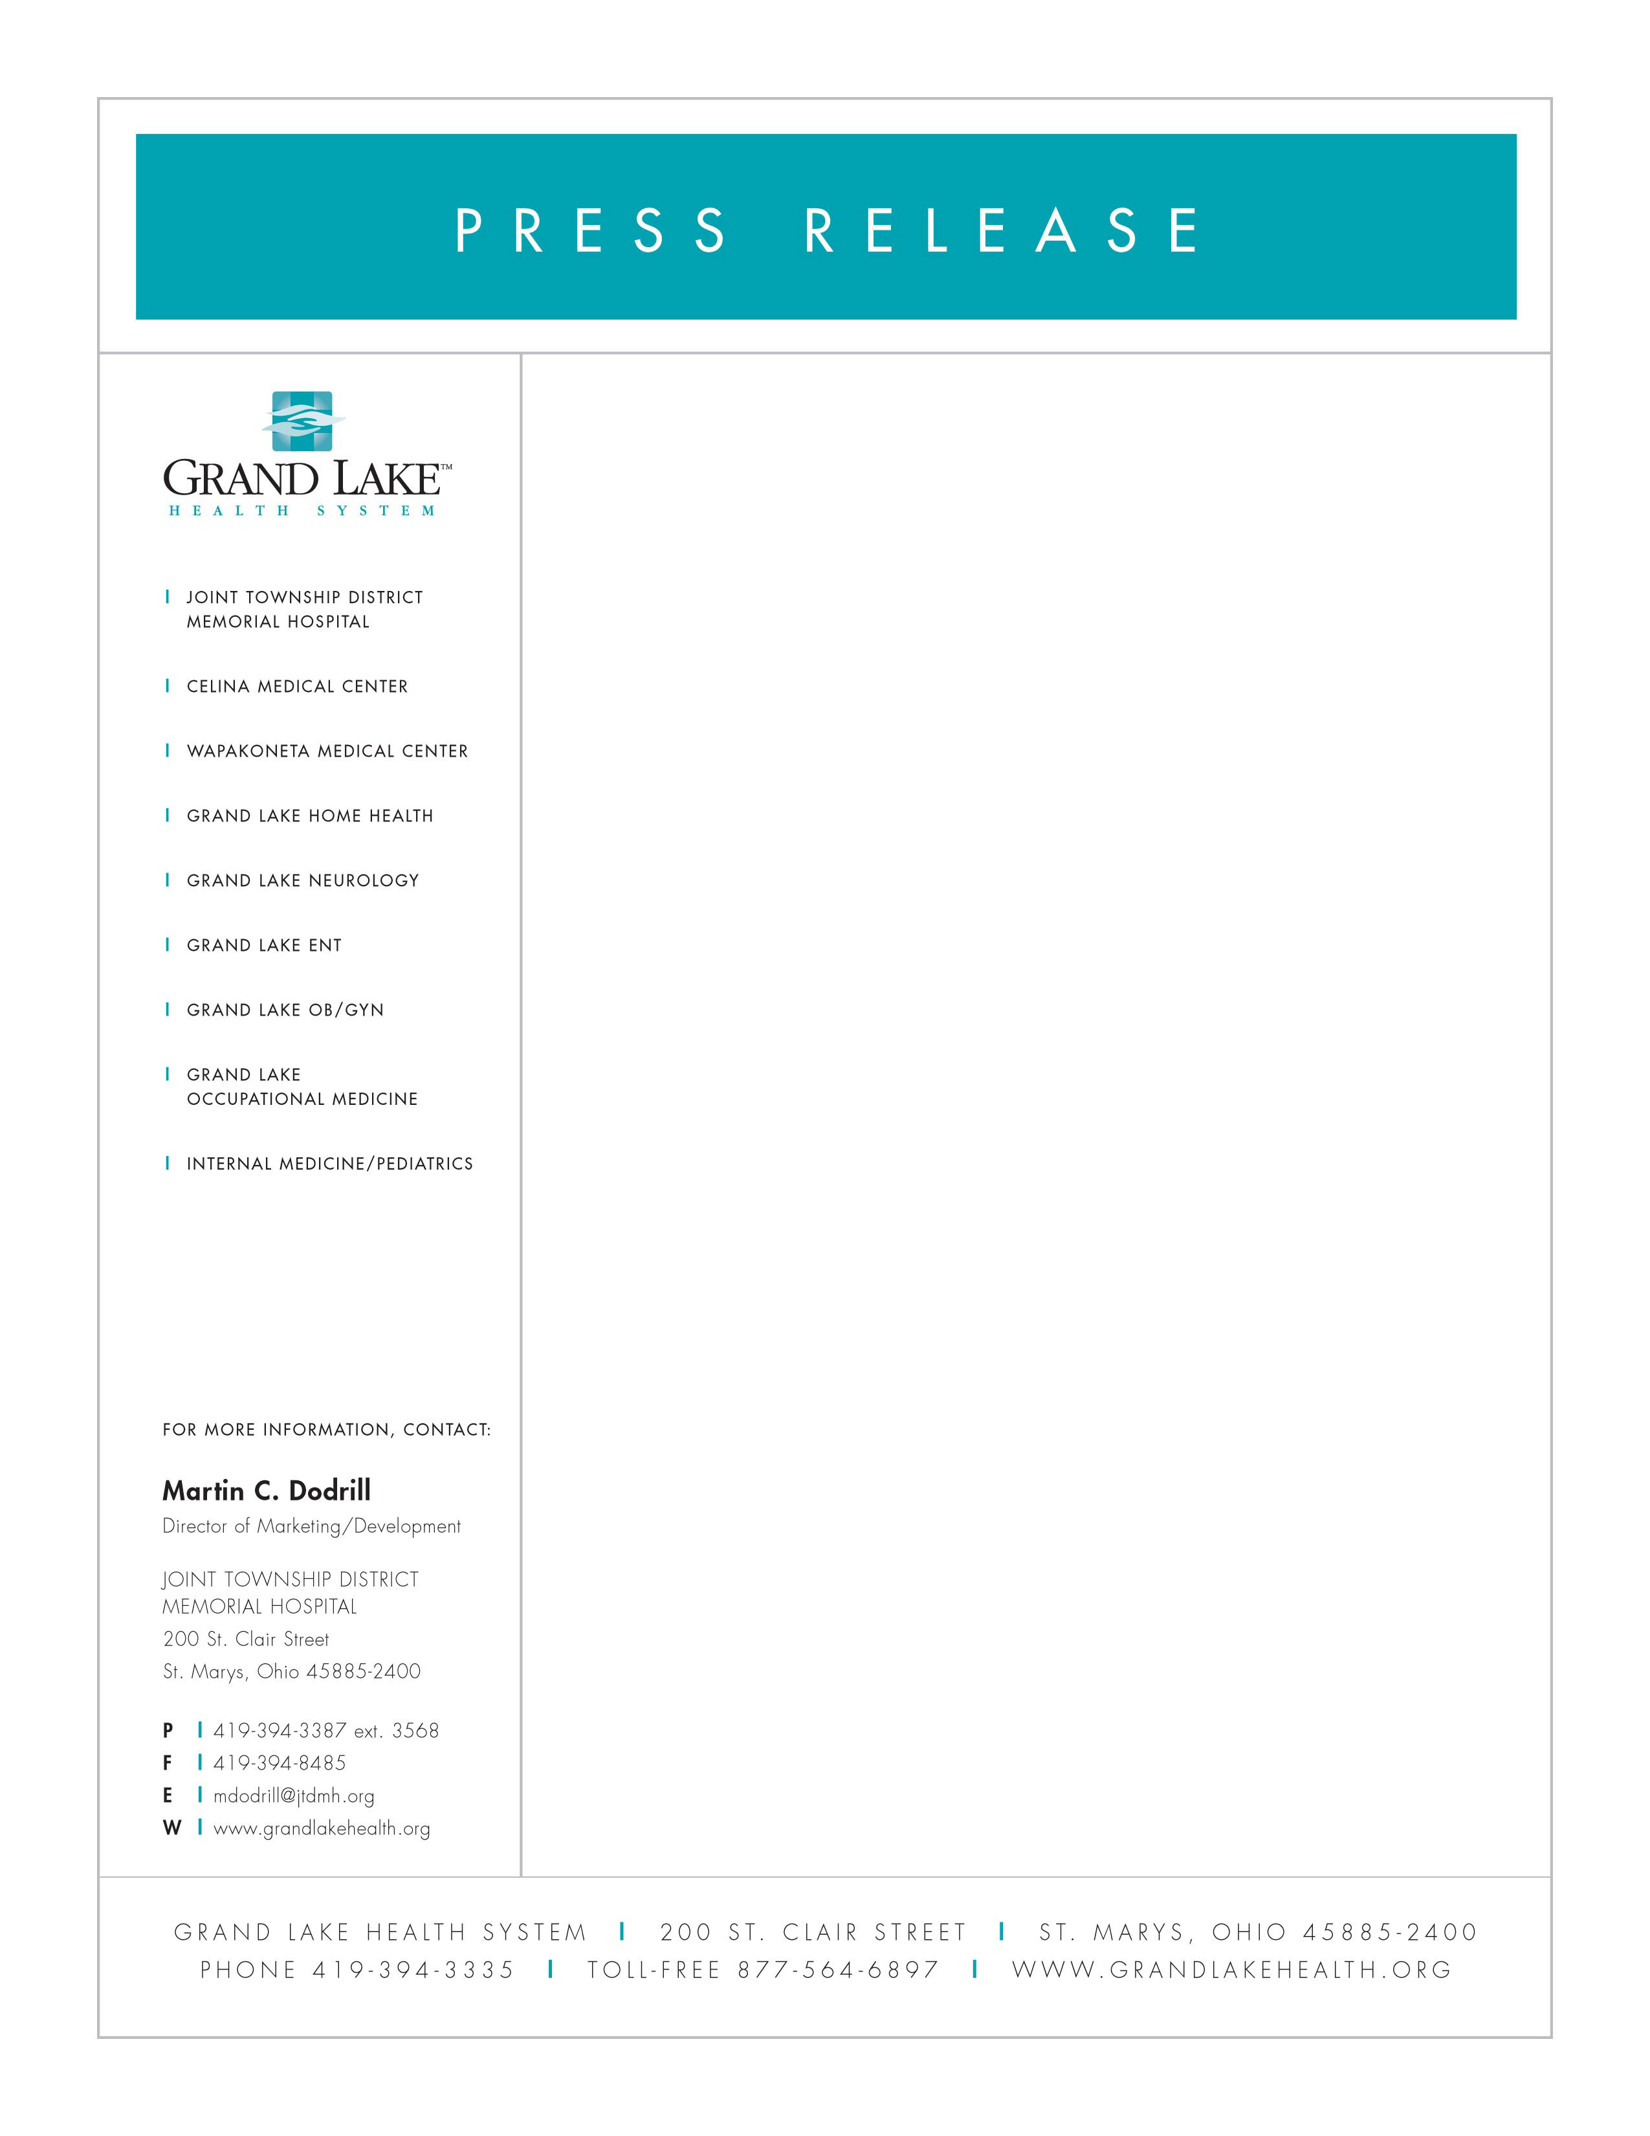
November 3, 2006

JTDMH GIFT SHOPPE TO HOLD CHRISTMAS OPEN HOUSE

You are cordially invited to attend the 2006 Christmas Open House at the JTDMH Gift Shoppe. This open house is to be held on Friday, November 17 from 7:00 a.m. to 4:00 p.m. The Shoppe will close at 4:00 p.m.

Come and see all our holiday items including snowmen, Santa’s, wreaths, greenery, nativity scenes, and Christmas trees. Take advantage of our 20% discount on holiday merchandise only, free refreshments and door prize drawings. All proceeds benefit the JTDMH Auxiliary.

Also available in the Gift Shoppe are the JTDMH Cookbooks, which feature a collection of recipes from hospital staff. The cost of the cookbook will be $5.00 and they make great holiday gifts.

