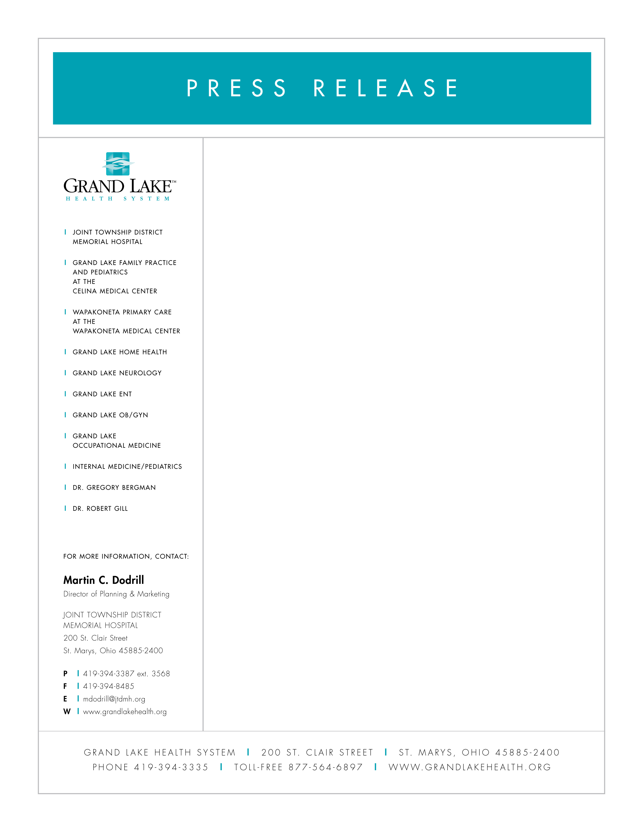

February 19, 2010

JOINT TOWNSHIP DISTRICT MEMORIAL HOSPITAL ECONOMIC IMPACT IS $84 MILLION

The 2009 Economic Impact Report, based on 2008 data, demonstrates the role of the Grand Lake Health System and Joint Township District Memorial Hospital in serving as economic leader in the Grand Lake Region through high quality jobs and infrastructure investment. This economic impact is a major source in economic growth for the entire region.

The Grand Lake Health System participated in the annual economic impact report of the Greater Dayton Area Hospital Association (GDAHA) and the University of Cincinnati Economic Center for Education and Research.

The 2009 Joint Township District Memorial Hospital Economic Impact Report details an $83.6 million total economic impact in the Grand Lake region. The total economic impact for Joint Township District Memorial Hospital included a direct impact of 656 employees at the Hospital with an overall impact of 872 employees. Wages and benefit expenditures provided a $27.9 million direct impact to the local economy. An additional $8.6 million impact from indirect and indirect wage and benefit expenditures resulted in a total household impact of $36.5 million.

Operationally, the direct impact of Joint Township District Memorial Hospital’s expenditure totaled $55.2 million for staffing, goods and services. The Hospital’s indirect expenditures also generated an additional $19.3 million of economic activity. Capital investments for construction, information technology and capital equipment totaled $6.8 million which also created an additional $2.3 million of economic activity in the region.

-continued-

Kevin Harlan, President and CEO of the Grand Lake Health System and Joint Township District Memorial Hospital stated “this report emphasizes what we always suspected, but prior was unable to present its impact in dollars. What sets apart the Grand Lake region, from other rural areas in Ohio, is our hospital and health system. It is a model economic driver for other organizations across the state.”

For more information regarding the 2009 Joint Township District Memorial Hospital Economic Impact Report, please visit www.grandlakehealth.org. To learn more about GDAHA’s 2009 Economic Impact Report, please visit www.gdaha.org.

About Joint Township District Memorial Hospital and Grand Lake Health System: Proudly committed to serving the community with compassionate care, advanced technology and expertise, Grand Lake Health System is a comprehensive health system offering a wide range of primary, acute and therapy services to the people of the Grand Lake region. Joint Township District Memorial Hospital offers: modern facilities, state-of-the-art equipment; caring medical professionals; high qualified, experienced physicians; the widest array of medical services and specialties – all with quality and convenience. Joint Township District Memorial Hospital and Grand Lake Health System remain committed to our long tradition of serving you with skill, expertise, quality, care and compassion.

