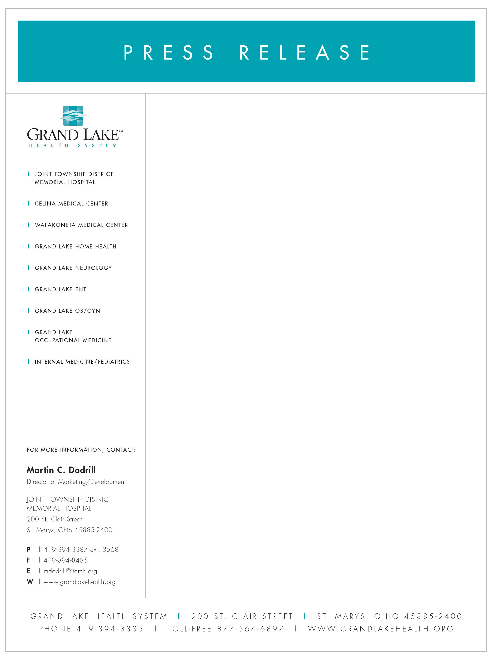

November 10, 2006

CELINA MEDICAL CENTER EXPANDING

The Grand Lake Health System and Joint Township District Memorial Hospital announced the expansion of the Celina Medical Center. The 10,000 square foot Celina Medical Center is located directly behind the Grand Lake Regional Cancer Center co-owned by Joint Township Hospital.

The planned expansion will add an additional 15,000 square feet, which will include physician offices as well as traditional hospital outpatient services. “The physician practices at the Celina Medical Center have experienced tremendous growth and this success has led to the planned expansion as well as additional services to meet community needs”, says Kevin Harlan, President and CEO of Grand Lake Health System and Joint Township District Memorial Hospital.

The offices of Dr.’s Roode, Josey, Swarts and White are the largest primary care practice in Mercer and Auglaize counties. They will receive new offices as well as planned expansion for other physicians currently serving Celina.

New space is being planned for a comprehensive medical imaging department, physical therapy department, urgent care and potentially a surgery center. The medical imaging department may include CT, MRI, ultrasound, mammography and basic x-ray.

The Grand Lake Health System and Joint Township District Memorial Hospital is the preferred choice for healthcare services in the Grand Lake Region with over 750 medical professionals, 120 physicians and eight centers of excellence. The Grand Lake Health System has medical facilities in Celina, St. Marys and Wapakoneta anchored by Joint Township District Memorial Hospital.

