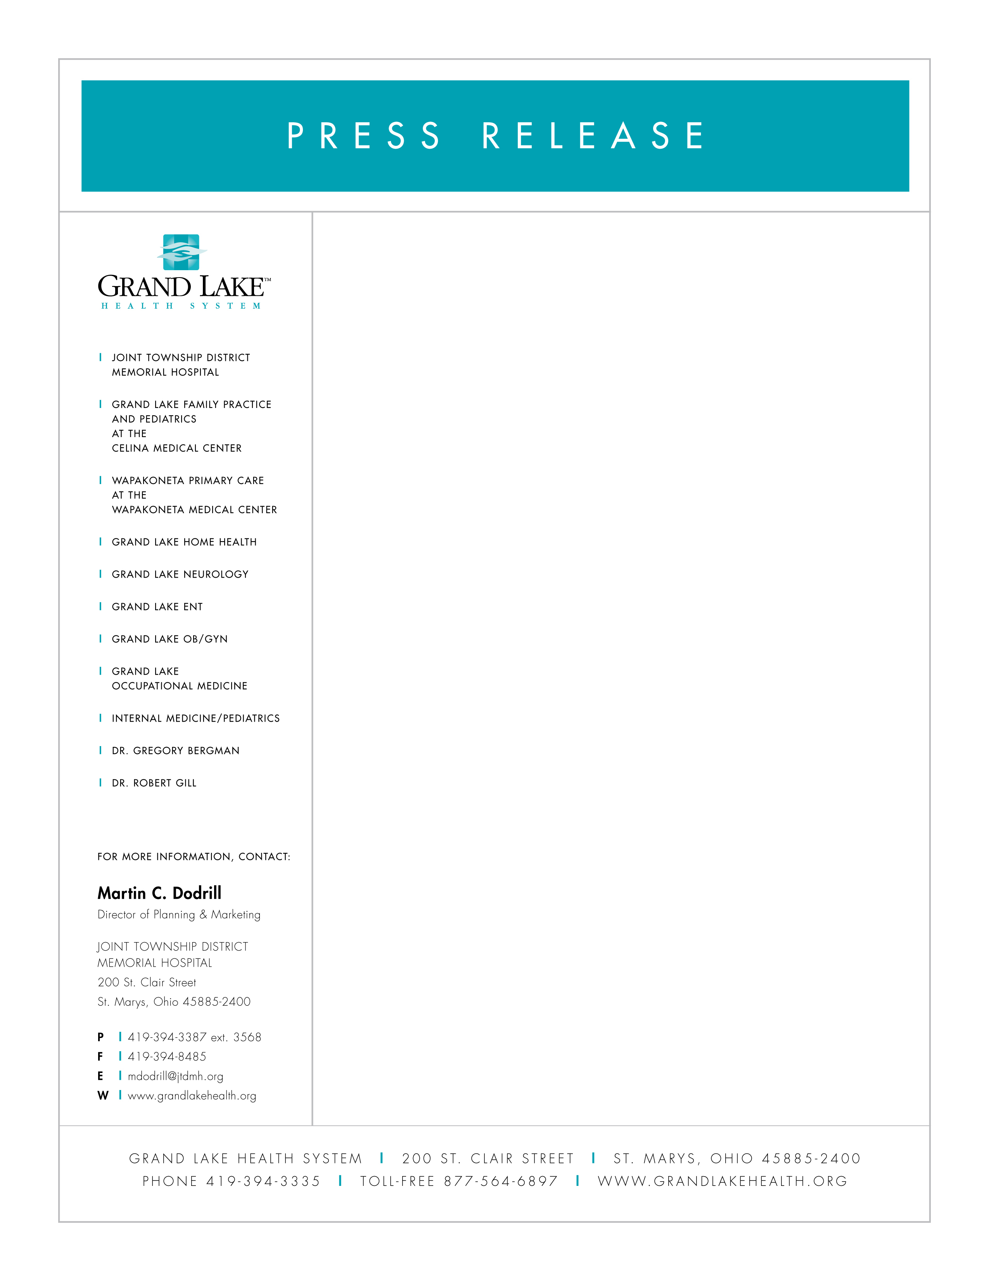

April 2, 2008

New Hours for Urgent Care

The Grand Lake Health System announced new hours for the Urgent Care service at Joint Township District Memorial Hospital. The hours for Urgent Care located adjacent to the Hospital’s Emergency Center will be 5:00 pm to 10:00 pm, Monday through Friday and 10:00 am to 10:00 pm on Saturday and Sunday, effective May 5. The Grand Lake Health System, also plans to open soon an Urgent Care service at the Wapakoneta Medical Center on Redskin Trail in Wapakoneta.

Urgent Care performs a valuable healthcare service that’s positioned between the doctor’s visit and the hospital ER. Visit JTDMH Urgent Care for treatment of the following:
- Abrasions, cuts, bumps or bruises,
- Sore throat or eat infections,
- Cough, cold symptoms or fever,
- Nausea and vomiting that’s not severe or debilitating,
- Sprains or muscle strains,
- Minor burns,
- Urinary tract infections,
- Minor eye injuries,
- Small bone fractures.

