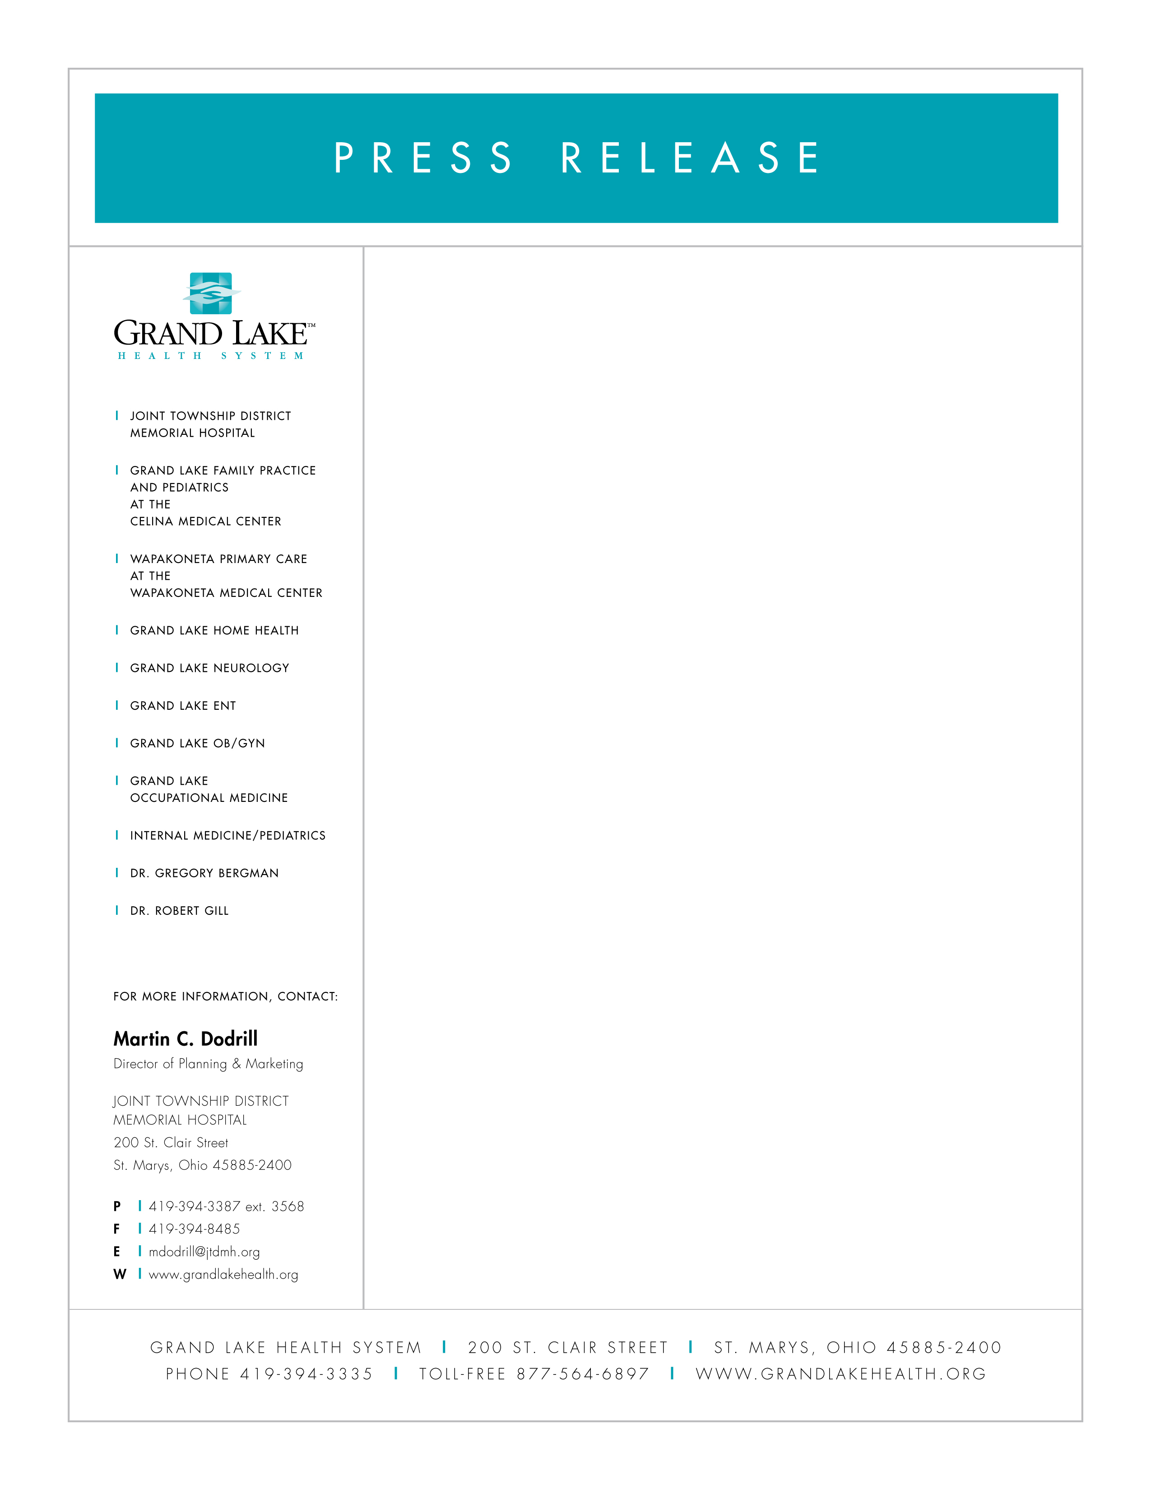

Larger Nominated as Healthcare Worker of the Year

Anne Larger of Joint Township District Memorial Hospital and the Grand Lake Health System has been nominated as the Ohio Hospital Association’s (OHA) Healthcare Worker of the Year. Along with 70 additional nominees from hospitals around Ohio, she will be recognized at the OHA’s recognition dinner on June 9 in Columbus.

Anne, an R.N., is the Community Outreach Coordinator at Joint Township Hospital and directs the Grand Lake Health System’s community programs including health fairs, school education programs, Senior Supper Hour, community health screenings and the Grand Health Challenge.

Kevin Harlan, President and CEO of Joint Township Hospital and the Grand Lake Health System says, “Anne is a star performer in expressing and acting out the Mission, Vision and Values of the Grand Lake Health System and all Ohio hospitals. In her role as Community Outreach Coordinator, she projects a passion and inspiration to all who work with or for her. Anne’s initiation of new programs, maintaining valuable relationships through continuing programs and addressing community health issues have made a significant impact on our Grand Lake region.”

Anne Larger is passionate about the Hospital’s Community Outreach program and realizes the value of her work and how it can impact the lives of those in the service area. She loves what she does and enjoys making a difference everyday. As Edith Wissman, volunteer and JTD Hospital Foundation Board Director says, “One thing which has always impressed me about Anne is her willingness to try new and suggested ideas and then pursue them with enthusiasm plus.”

Anne is involved in many community activities. She is an avid member and strong supporter of the New Bremen/New Knoxville Rotary Club. She gives her service in many ways through her church and other organizations which she belongs including the Auglaize County Council on Aging, Giving Thanks, St. Marys Area Chamber Board of Directors, American Cancer Society Board of Directors, Heart Health Coalition of Auglaize County, Regional Tobacco Free Coalition and Action for Healthy Kids.

Anne and her husband Larry live in Minster having raised four sons and are now very active with their six grandchildren. As Anne says, “they are all wonderful gifts, the light of my life.”

