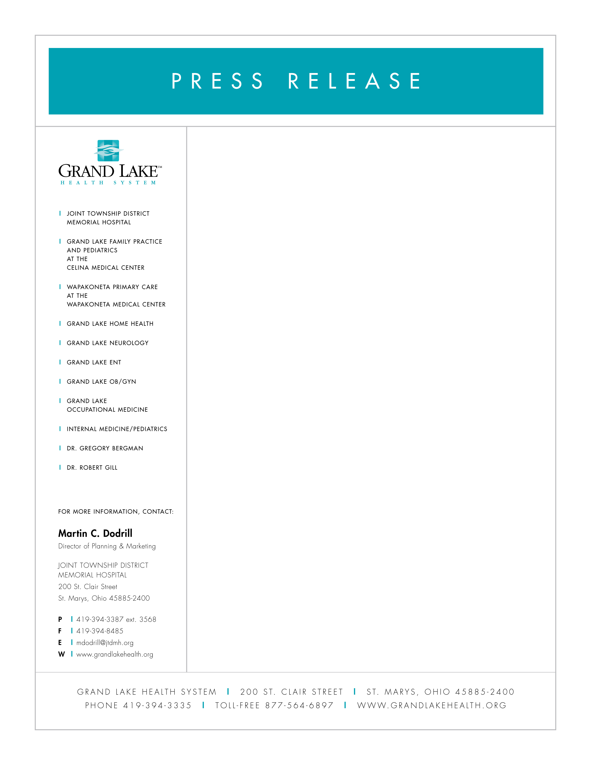
February 4, 2009

INGRAHAM APPOINTED TO HOSPITAL BOARD

Susan Ingraham has been appointed to the Board of Directors of Joint Township District Memorial Hospital, St. Marys. Ingraham is a free-lance court reporter and one of three principals in Midwest Reporting Service.

Kevin Harlan, President and CEO of Joint Township District Memorial Hospital and Grand Lake Health System, says, “Susan will be a valuable addition to our Board of Directors in assuming a continuation of high quality and efficient services to our community.”

Ingraham lives in Celina with her husband Jeffrey. She is an active member of St. Paul’s United Methodist Church, the Society for the Technological Advancement of Reporting, and she and her husband enjoy being a host family for the college summer league baseball team, the Grand Lake Mariners.

“I am excited about helping this excellent health care system maintain its presence and focus in the area, and look forward to helping the hospital build even more solid relationships in the future,” says Ingraham.

Joint Township District Memorial Hospital and Grand Lake Health System, provides comprehensive, excellent and accessible healthcare throughout the grand lake region. Additional information is available at www.grandlakehealth.org.

