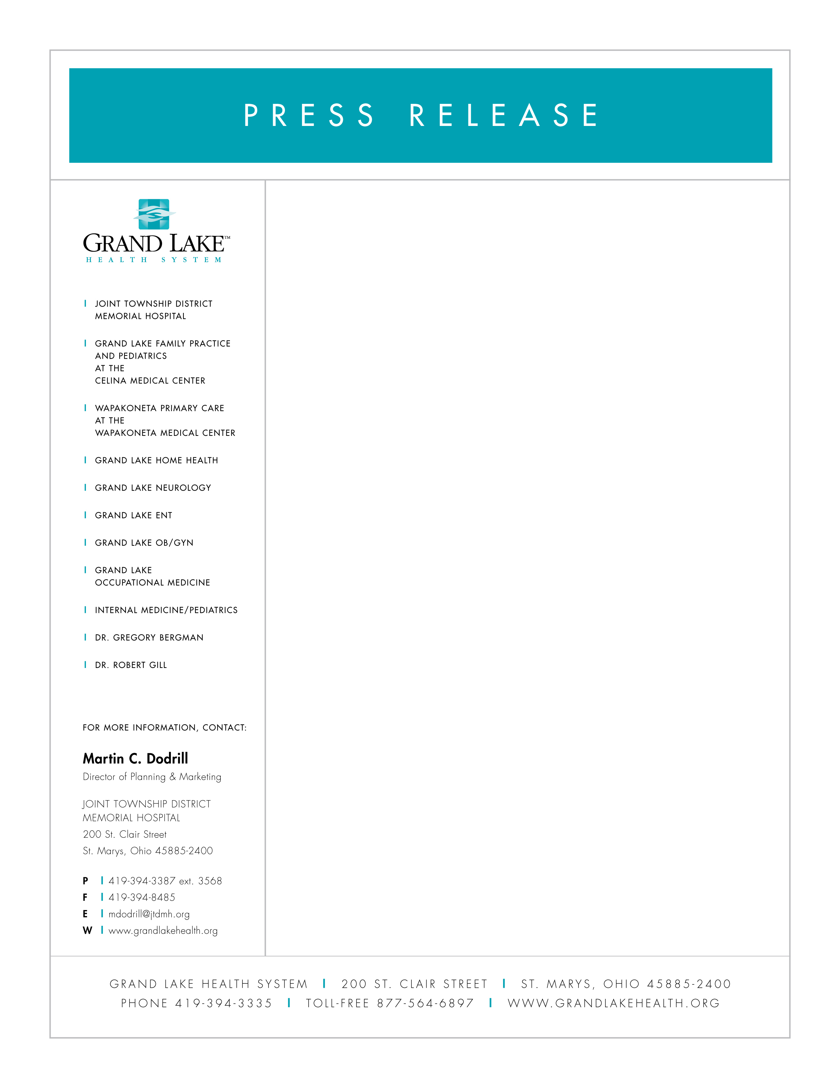

March 27, 2008

DR. MCNAUGHTON JOINS GRAND LAKE HEALTH SYSTEM

Dawn P. McNaughton, M.D., has joined Grand Lake Primary Care at St. Marys in practice with Cynthia Gaerke, M.D. “We welcome Dr. McNaughton back to the area and Grand Lake Health System,” says Kevin Harlan, President and CEO of Grand Lake Health System and Joint Township District Memorial Hospital.

Dr. McNaughton is a native of New Bremen, Ohio and has been in Cold Spring, Kentucky family practice. She is board certified in family practice and was a family practice resident at University of California Davis at David Grant Medical Center. Dr. McNaughton received her Doctor of Medicine from the University of Cincinnati College of Medicine and her B.S. in biology from Bowling Green State University.

“I look forward to moving back to the area and seeing family and friends on a day to day basis. I am excited to begin working with the Grand Lake Health System, Dr. Gaerke and her amazing health team”, states Dr. McNaughton.

Grand Lake Primary Care is located at 1040 Hager Street in St. Marys and has been the established practice of Cynthia Gaerke, M.D. since 1999. Grand Lake Primary Care is an affiliate of Grand Lake Health System and Joint Township District Memorial Hospital.

