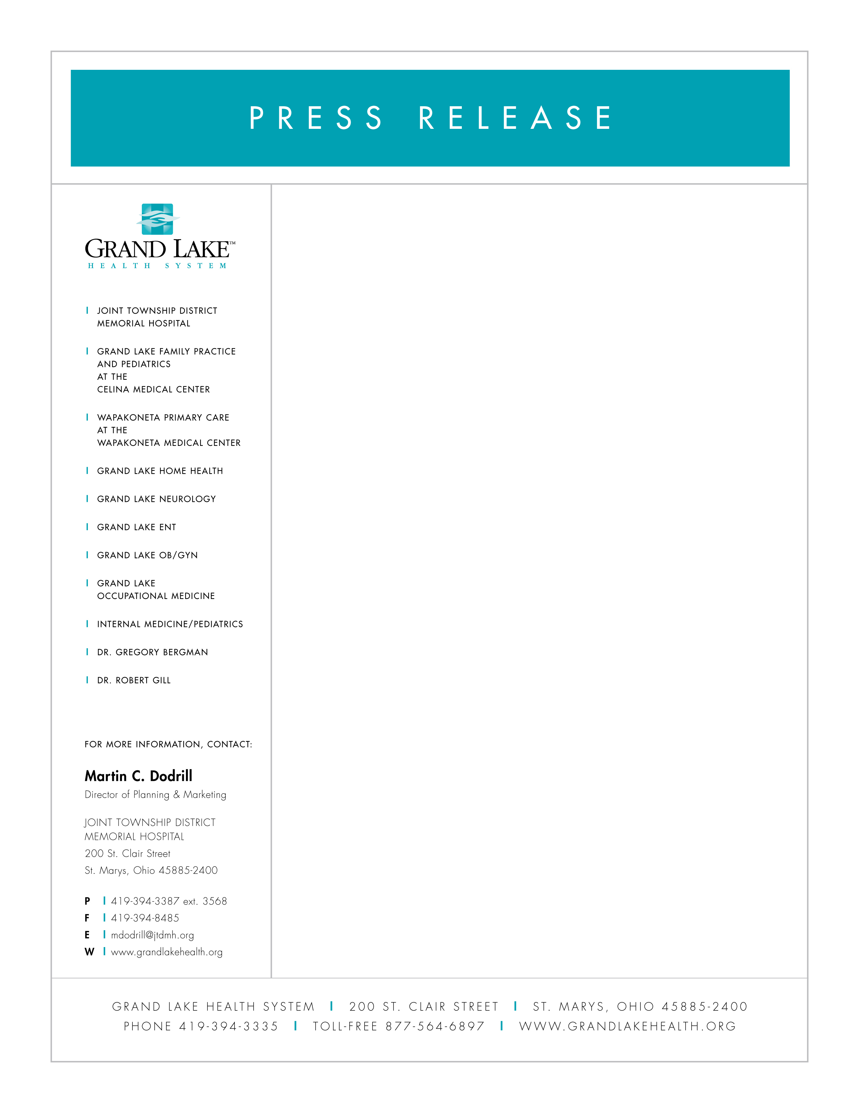

March 13, 2008

Dr. Fornadel Joint Grand Lake Health System

“The Grand Lake Health System is pleased to announce that Brian Fornadel, M.D. has been appointed Director of Urgent Care at Joint Township District Memorial Hospital,” says Kevin Harlan, President and CEO of the Health System and Hospital.

Dr. Fornadel is Board Certified by the American Board of Family Practice and comes to the Grand Lake Health System from a family practice in the Dayton, Ohio area. He received his M.D. from The Ohio State University College of Medicine and completed a family practice residency at Miami Valley Hospital in Dayton.

“It is a pleasure to be part of Joint Township District Memorial Hospital and to become a part of the Grand Lake community. I look forward to my work with the hospital and in Urgent Care. I will strive to provide the highest quality medical care associated with the Grand Lake Health System,” states Dr. Fornadel.

Urgent Care is located adjacent to the Emergency Center at Joint Township District Memorial Hospital. Urgent Care service hours are Monday through Friday, 5:00 pm to 12:00 am, Saturday and Sunday from 10:00 am to 10:00 pm.

Picture attached: Dr. Brian Fornadel

