### 

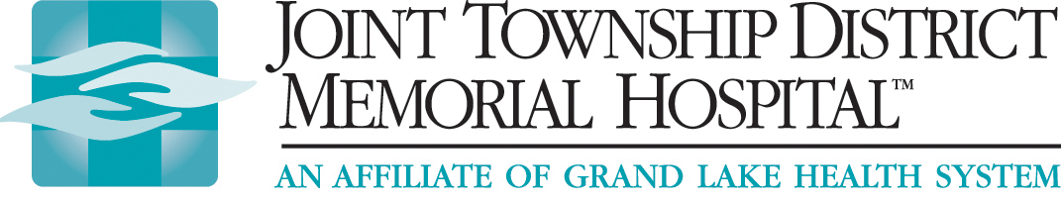

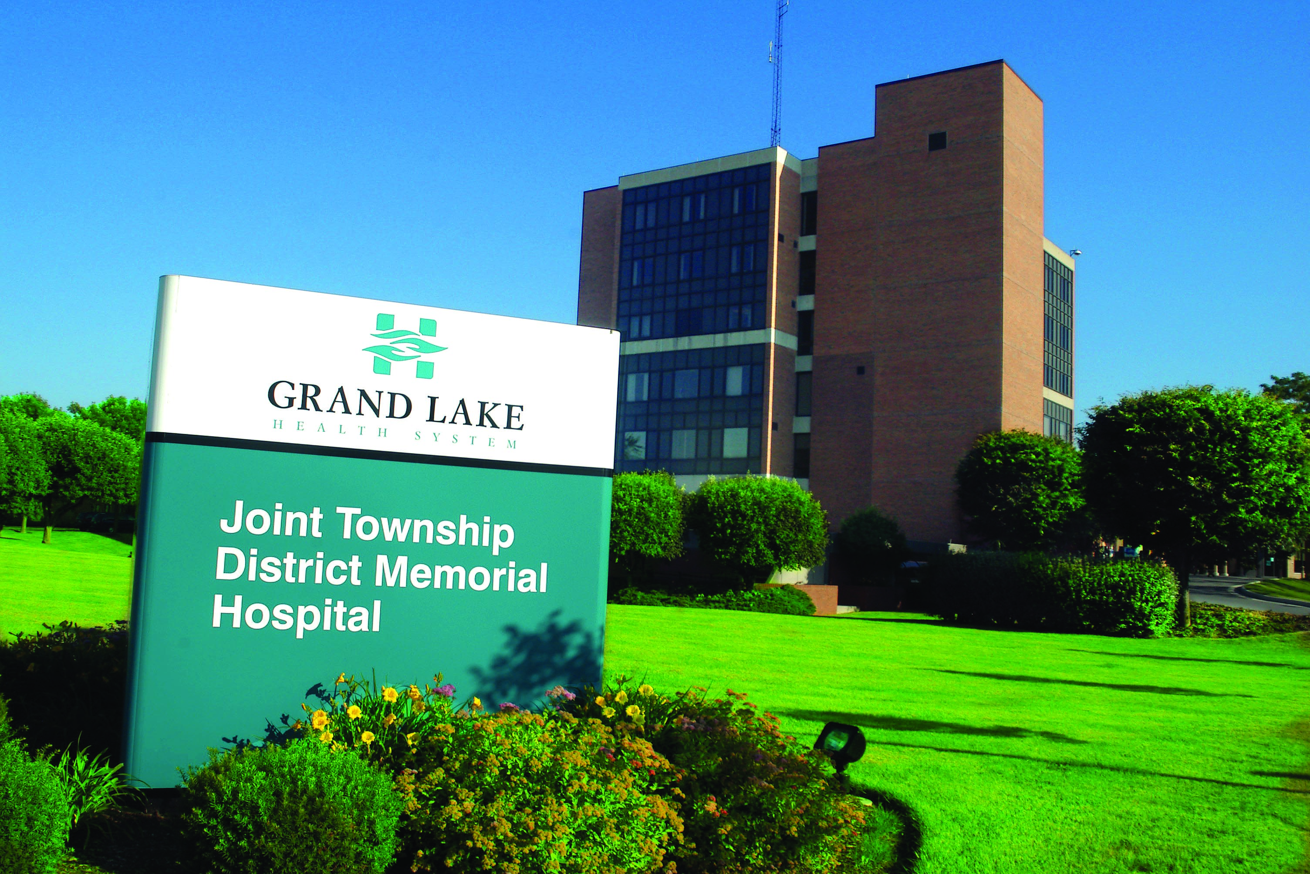

**BASIC LIFE**

**SUPPORT**

**CPR**

**2017 SCHEDULE AND REGISTRATION FORM**

**JTDMH is an American Heart Association Training Center and conducts public BASIC LIFE SUPPORT CPR classes. Classes are conducted at JTDMH and are taught by AHA instructors aligned with our Training Center.**

**BASIC LIFE SUPPORT CPR** classes are designed for professionals who require a CPR course, such as individuals or students in the healthcare field. After successful course completion, just one class, the appropriate AHA course completion card will be issued. You need to retake the course every 2 years to get a new course completion card.

* Each student is issued a course textbook for use before, during, and after the course.
* Each AHA course follows the AHA guidelines and core curriculum.
* You will apply the BLS concepts of the Chain of Survival and recognize the signs of someone needing CPR.
* You will learn the skills of CPR for victims of all ages through the workbook and video and will practice these skills many times.
* You will learn how to use an automated external defibrillator (AED) and relieve choking (foreign-body airway obstruction).
* You will perform high quality CPR and provide effective ventilation using a barrier device.
* You will perform as an effective team member during multi-rescuer resuscitation.
* Successful completion of the skills and written examination will meet course requirements.

|  |  |  |  |  |  |  |  |  |  |  |  |  |
| --- | --- | --- | --- | --- | --- | --- | --- | --- | --- | --- | --- | --- |
| **Monday**  **1230-430 PM** | **Jan 2** | **Jan 30** | **Feb 27** | **Mar 27** | **May 1** | **May 22** | **Jun 26** | **Jul 31** | **Aug 28** | **Sept 25** | **Oct 30** | **Nov 27** |
| **Saturday**  **800-1200 AM** | **Jan 14** | **Feb 18** | **Mar 18** | **Apr 22** | **May 13** | **June 24** | **July 22** | **Aug 26** | **Sept 23** | **Oct 14** | **Nov 11** | **Dec 9** |

***Class size is limited. No walk-ins accepted.***

***Registration and payment MUST BE RECEIVED AT LEAST 14 DAYS prior to the date of the course.***

**For more information call Linda Dicke RN 419-394-3387 ext 1224 or email ldicke@jtdmh.org**

**🖃 BLS CPR CARD WILL BE MAILED OR EMAILED WITHIN 30 DAYS FROM COURSE DATE. 🖃**

✂ ✂ ✂ ✂ ✂ ✂ ✂ ✂ ✂

|  |
| --- |
| **2017 BASIC LIFE SUPPORT CPR CLASS REGISTRATION FORM:**  Name: _____________________________ Address: __________________________________________  Phone: ____________________________ Email: _______________________ Date of Class: __________  ***Course Fee is $50.00. Make checks payable to JTDMH.***  **Send completed registration and payment to:**  **Linda Dicke-CPR Coordinator JTDMH 200 St Clair Street St Marys, Ohio 45885** |

The American Heart Association strongly promotes knowledge and proficiency in BLS, ACLS and PALS and has developed instructional materials for this purpose. Use of these materials in an educational course does not represent course sponsorship by the American Heart Association, and any fees charged for such a course, except for a portion of fees needed for AHA course materials, do not represent income to the association.