April 5, 2024

Date Change Announced – SIDS Awareness 5K Run/Walk 2024

The 2024 SIDS Awareness 5K Walk/Run (in memory of Landen) is moving to October 12, 2024.

This family friendly event is planned to raise awareness in our communities about the importance of safe sleep for infants. Proceeds from SIDS Awareness 5K are used to provide two yearly Landen Phlipot Nursing scholarships.

The event welcomes runners and walkers of all ages, through the beautiful fall scenery of the St. Marys River, Memorial Park and K.C. Geiger Park. Awards and prizes will be given across several categories. Participants and sponsors can register at https://runsignup.com/Race/OH/SaintMarys/SIDSAwareness5k .

For more information contact the JTD Foundation at 419-394-3387, ext 3567 or email
cwidman@jtdmh.org.

We would like to invite you to join us again as a SPONSOR for this important event. Your support makes a difference to the lives of our tiniest patients! Please see the sponsorship information enclosed. We invite you to bring a group from your business and make this a healthy work activity supporting healthy families.

Door prize donations are welcome and appreciated. All net proceeds from this event will be directed to the Landen Phlipot Nursing Scholarship Fund.

Please return the enclosed sponsorship information by Friday, September 27. We look forward to hearing from you!

Sincerely,
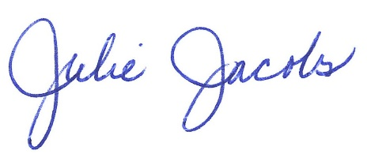

Julie Jacobs, CFRE, CDVS
Executive Director

2024 SIDS Awareness 5K Committee: Tracy Smith – Chair, Amy Becker, Denise Limbert, Kristy Peggs, Stefanie Lowry, Carrie Widman

